The Election: Jesus calls for "War Spiritually"
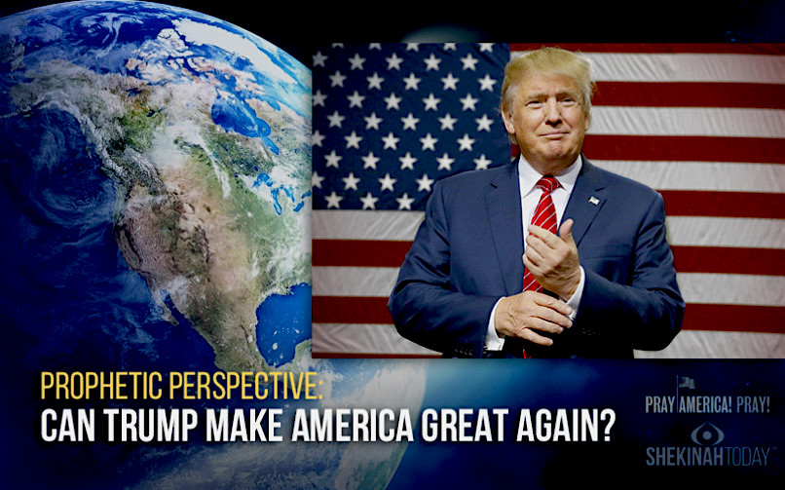
November 6, 2016

May our King Jesus give us the strength and the weapons of spiritual warfare sufficient to win this election.

The Lord began, "You are now facing the biggest political turn around since the Iron Curtain fell. It is time for this country to overcome the obstacles of the past and make the best of the mess left by the Masons. Dear ones, remember this country was founded on occult principals, not Christian ones.

"There is a fight and a war going on in the heavens and on the Earth for control of the Earth. The only way to wage this war is spiritually, and of course, taking action and casting your votes. But I need My Church in prayer for the next three days as the battle comes to a conclusion.

"The enemy is giving this everything he’s got to keep control, which I must say isn’t much by My standards. But it is enough if people do not pray and fast and spiritually war against the forces I want to thrust out of power. Many of My prophets and apostles have gone into seclusion to fast and pray against these powers. For you, My Dear ones, I ask you to be led by My Spirit and give all you can to this battle.

"Nothing is too small. Children who offer prayers are far more powerful than many adults, because of the purity of their souls. So, I am asking you parents to bring your children into your prayer circles and explain to them as best you can, exactly what is at stake.

"Tell them that Satan has been working secretly in this country to destroy it. The forests, lakes, rivers and oceans. He and his minions have been responsible for the earthquakes and weather changes, beached animals and fish. Aborted babies. The poisoning of the Earth so babies come out deformed. Use discretion, but make it clear to them that their future depends on this election - whether or not there will be freedom in this country. Whether or not ISIS will take over this country and murder Christians.

"Of course their minds are tender, but they should know how very serious this is without causing them damaging distress. Just enough to get them to pray in earnest. The Divine Mercy Chaplet is powerful. Tears are powerful, vigils are powerful. Supplication with loud cries to Heaven are powerful. Denying yourselves food is powerful, fasting for those who can fast is powerful. Offering sacrifices, television, dessert, shopping, every form of self-denial will have an impact on this election.

"This is not just for the sake of denying yourselves pleasure. No, this is for sharpening your spiritual vision and being united to Me as I, too, enter into the sufferings and the warfare of My people to turn this country and the world around.

"You who are blessed with the cross of sickness, which you carry knowingly, are among the most powerful of My intercessors, because you have offered your own bodies as a living holocaust to bring Heaven to Earth. I am with you and will multiply graces released on your behalf.

"Those of you who are suffering morally: wrongfully accused, unjustly incarcerated, discriminated against, beaten and imprisoned for your faith, experiencing persecution from relatives for your faith, losses of homes and goods through unusual weather conditions. All these sufferings, every single one can be offered to My Father for this election.

"Nothing is too small to be regarded as an offering. Nothing. The loss of a beloved pet, altercations at school, toothaches. All of these things, when offered together, all through this nation are tremendously powerful.

"And as My Father looks upon your sacrifices and offerings, His heart is moved to pity and more angels are dispatched, more graces, more protection for the candidates. Everything is increased with the tears of My People.

"Do not allow yourselves to be distracted or thrown off course. There is nothing you can do for the next three days, that will more impact your life and the future, for the better, than prayers and sacrifice and your vote for this nation.

"Those who receive communion daily, offer your communion for Donald Trump’s victory in the election and for the safety of him and his family.

"Right now, in this hour, much is being planned and protected and those who are attempting to destroy the sovereignty of this country, and all countries around the world, are running into obstacle after obstacle after obstacle. This is the power of prayer in action. Things have been put into action that could hold back the tide of evil for a decade. That’s how much prayer and martyrdom and sacrifice has gone forth to reverse the direction of Satan and his minions.

"This has nothing to do with the Rapture, and everything to do with individual freedoms in this nation and around the world.

"My Body has been immensely powerful in opposing the schemes of the enemy, now that they have been exposed for the people of the world to see. That does not mean we have the victory, it means only that prayer is working and needs to be applied more at this critical hour in the world.

"So, My Beloved ones, continue to pray. Continue to hope. Continue to have faith and stir others to action for these decisive days.

"I am with you in your prayers, and no sacrifice goes unnoticed. All ascends to the Father as incense, fragrant and moving Him to arise against your foes."

